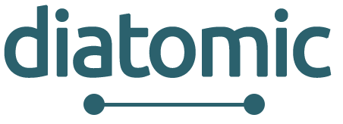
DIGITAL INNOVATION HUBS BOOSTING EUROPEAN MICROELECTRONICS INDUSTRY - DIATOMIC -
Annex 5: Consortium & Honour Declaration
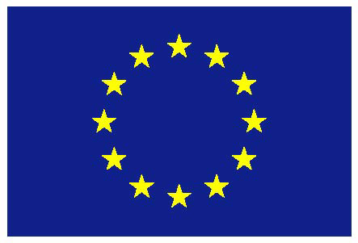 | This project has received funding from the European Union’s Horizon 2020 research and innovation programme under grant agreement No. 761809. |  |  | European Smart Anything Everywhere Initiative

Consortium Declaration

Title of the Project: ________________________________________________________

On behalf of _____________________________(Company name) established in ______________________________, (Official address), VAT/TAX number_________________, represented for the purposes of signing and submitting the Declaration by ___________________________ (Name of legal representative), declares that all provided information below is true and legally binding.

- The Consortium leader declares that all Consortium partners have agreed on their roles and budget shares.
- The Consortium leader is solely responsible to distribute the budget shares to Consortium partners in accordance to this Consortium Declaration.
- DIATOMIC Consortium bears no responsibility in case the Consortium leader violates the mutual agreement set in this Consortium Declaration.
- DIATOMIC Consortium bears no responsibility in case of dispute among consortium partners regarding IP rights.
By signing this declaration, the industrial partners of the consortium declare that they are not members of any other competitive Consortium in DIATOMIC Open Call 1. In case, industrial partners of the consortium participates in more than one Consortia, all associated proposals will be automatically excluded from the evaluation process.
By submitting this document, the Consortium accepts all the rules explained in DIATOMIC Guidelines for Applicants.
Coordinator Leader Contact Information:
Title (Mr, Mrs, Dr.)
Name
Surname
Job Title
Affiliation
Full Address
Country
Email Address
Telephone
Mobile
Signature and stamp

Declaration of Honour on exclusion criteria and
absence of conflict of interest
All participants signing this declaration of honour declare that all provided information below is true and legally binding:

1. Declares that is not in one of the following situations:
- it is bankrupt or being wound up, is having its affairs administered by the courts, has entered into an arrangement with creditors, has suspended business activities, is the subject of proceedings concerning those matters, or is in any analogous situation arising from a similar procedure provided for in national legislation or regulations;
- it or persons having powers of representation, decision making or control over it have been convicted of an offence concerning their professional conduct by a judgment which has the force of res judicata;
- it has been guilty of grave professional misconduct proven by any means which the contracting authority can justify including by decisions of the European Investment Bank and international organizations;
- it is not in compliance with its obligations relating to the payment of social security contributions or the payment of taxes in accordance with the legal provisions of the country in which it is established or with those of the country of the contracting authority or those of the country where the contract is to be performed;
- it or persons having powers of representation, decision making or control over it have been the subject of a judgment which has the force of res judicata for fraud, corruption, involvement in a criminal organization or any other illegal activity, where such illegal activity is detrimental to the Union’s financial interests;
- is subject to an administrative penalty for being guilty of misrepresenting the information required by the contracting authority as a condition of participation in a grant award procedure or another procurement procedure or failing to supply this information or having been declared to be in serious breach of its obligations under contracts or grants covered by the Union's budget.

- Declares that:
- is not subject to a conflict of interest;
- has not made false declarations in supplying the information required by the as a condition of participation in the Open Calls of DIATOMIC Project or does not fail to supply this information;
- is not in one of the situations of exclusion, referred to in the abovementioned points a) to f).
- Is aware and fully accepts all DIATOMIC condition and rules as expressed in DIATOMIC open call documents Annex 1, Annex 2, Annex 3 and Annex 4.

- Certifies that:
- is committed to participate in the abovementioned project;
- has stable and sufficient sources of funding to maintain its activity throughout its participation in the above-mentioned project and to provide any counterpart funding necessary;
- has or will have the necessary resources as and when needed to carry out its involvement in the above-mentioned project;
- no Consortium partner has received an amount greater or equal to 100.000 EUROs in total (including this proposal) via open calls of H2020 I4MS or SAE projects.

- Consortium leader
Company name
Full address of the company
Country
Name of legal representative
Project Budget share
Legal representative signature and stamp

- Consortium partner No 2
Organization name
Full address of the organization
Country
Name of legal representative
Project Budget share
Legal representative signature and stamp

- Consortium partner No 3
Organization name
Full address of the organization
Country
Name of legal representative
Project Budget share
Legal representative signature and stamp

